Fencing in your School!

For over a decade, Tri-City Fencing Academy has operated Youth Fencing Programs in Port Moody, Coquitlam, and Port Coquitlam. The Academy’s staff of professional coaches and instructors delivers an educational and engaging sports experience in all of District #43’s public Recreation Centres. We have over 150 students training and competing at local, provincial, national, and international levels.

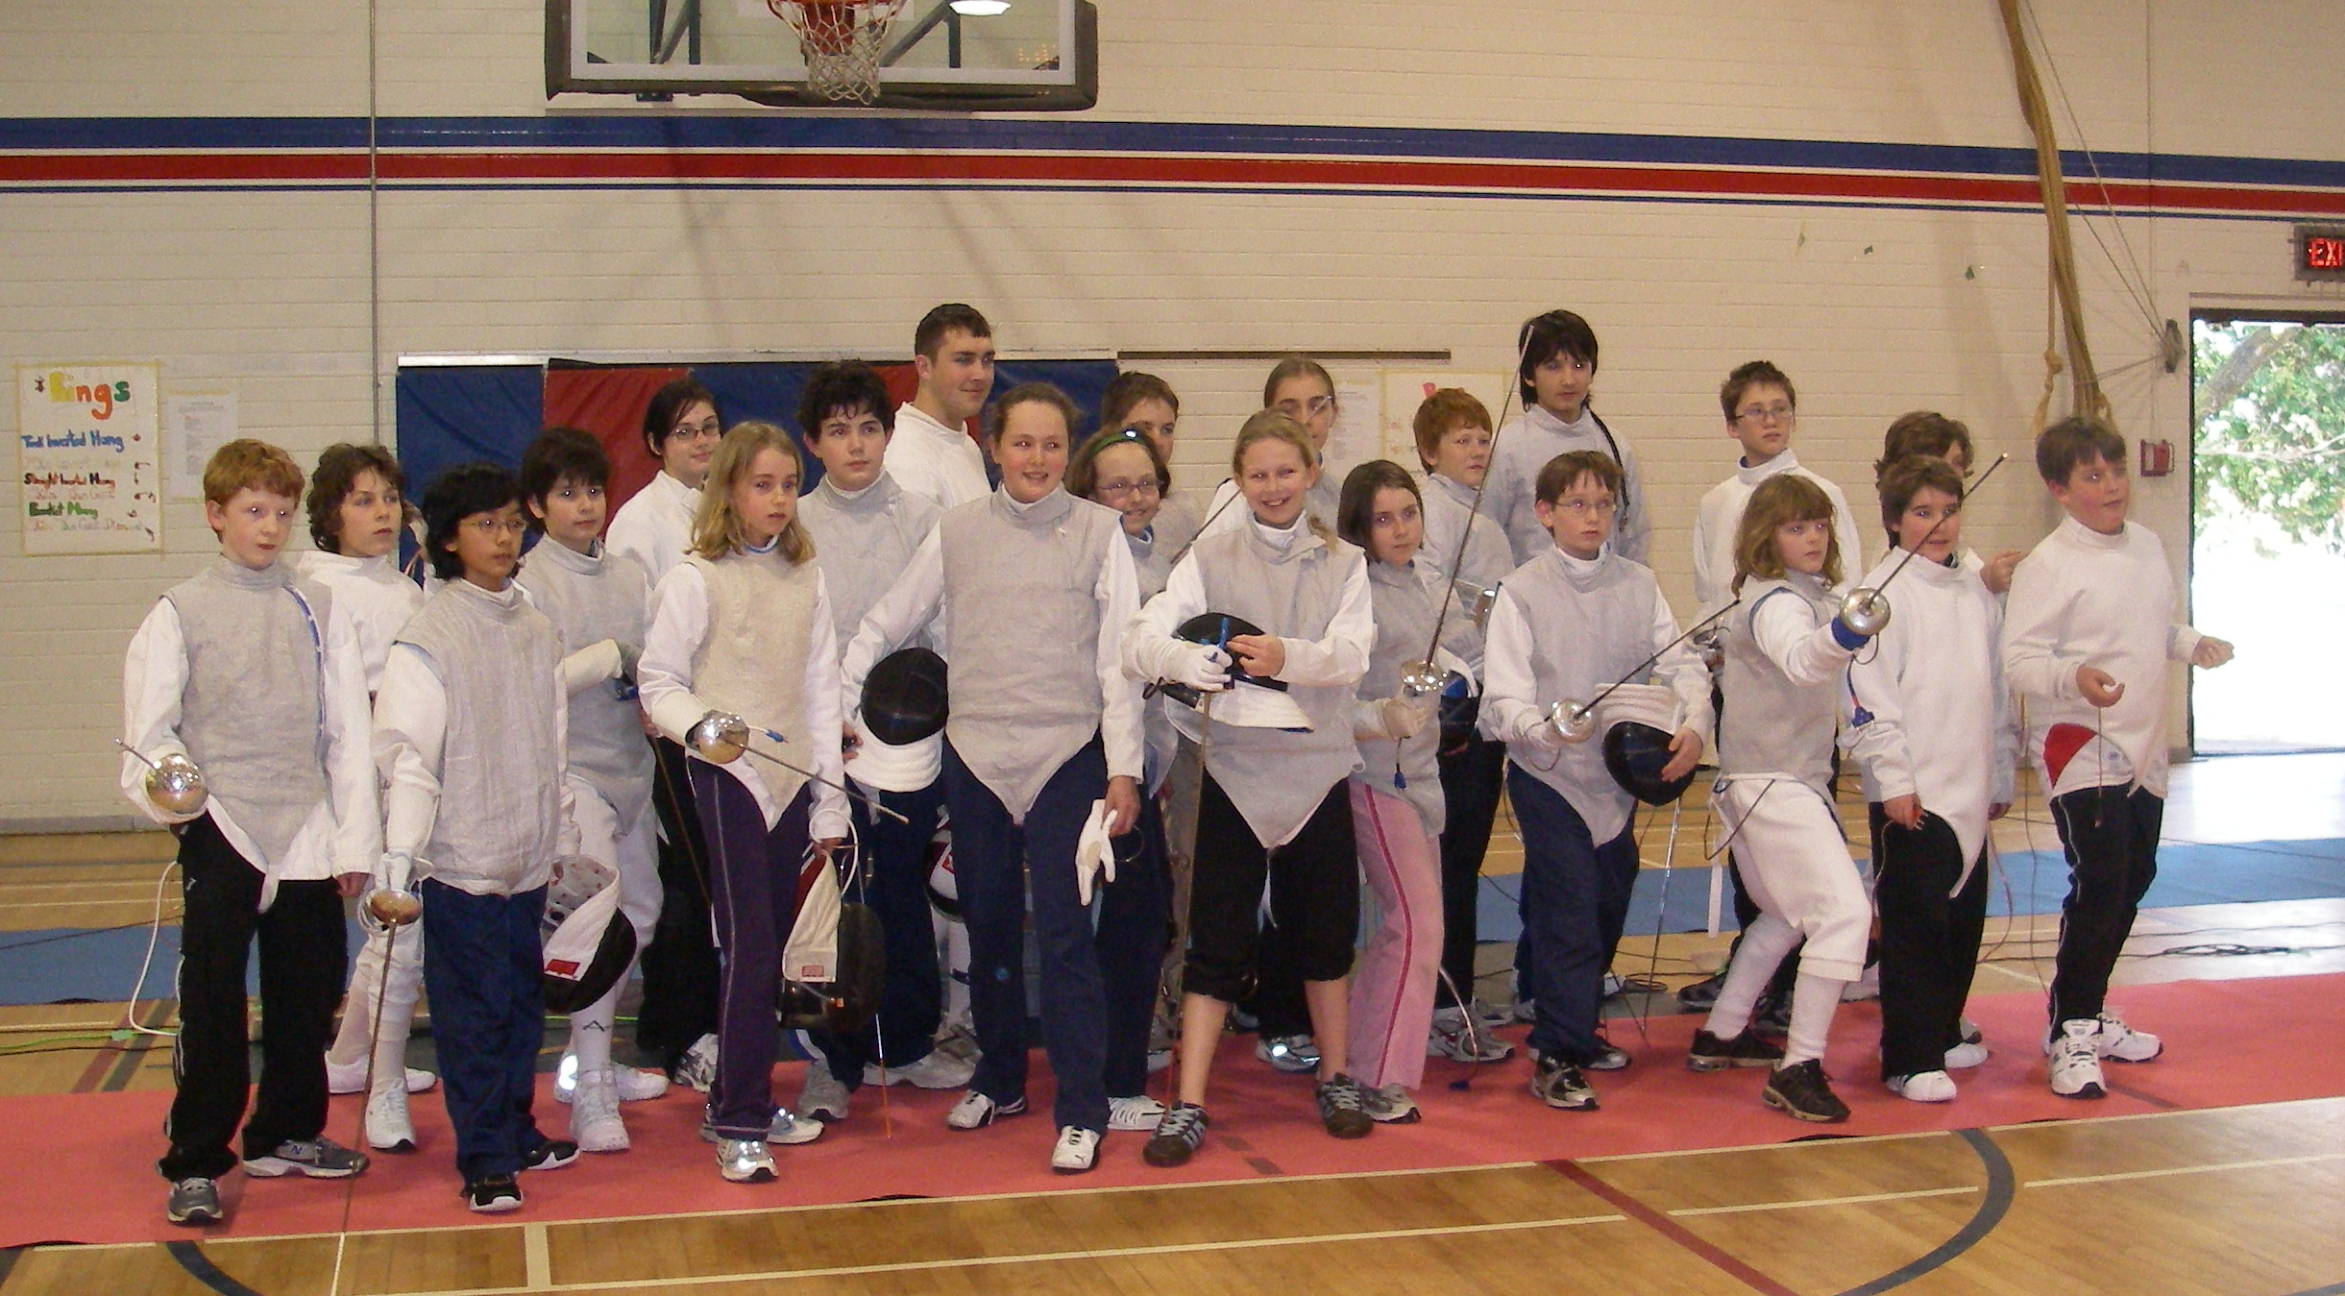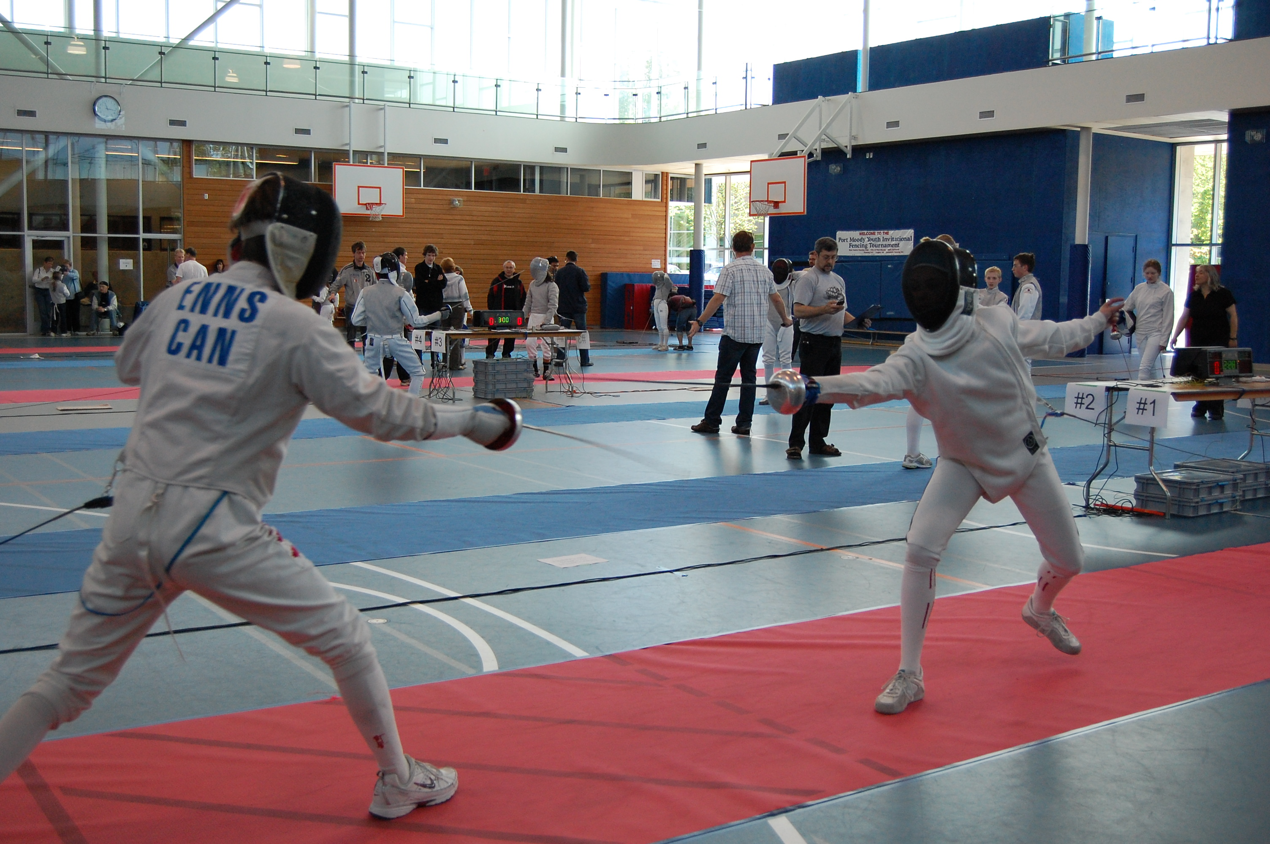

Through our public and school beginner classes, we bring the sport to youths 8-18 years old - over 2,000 students per year! We have worked with many schools in the District and are bringing our programs to your grade 4 and older students. We provide a fun, structured and competitive sports environment, suitable for students of all fitness levels.

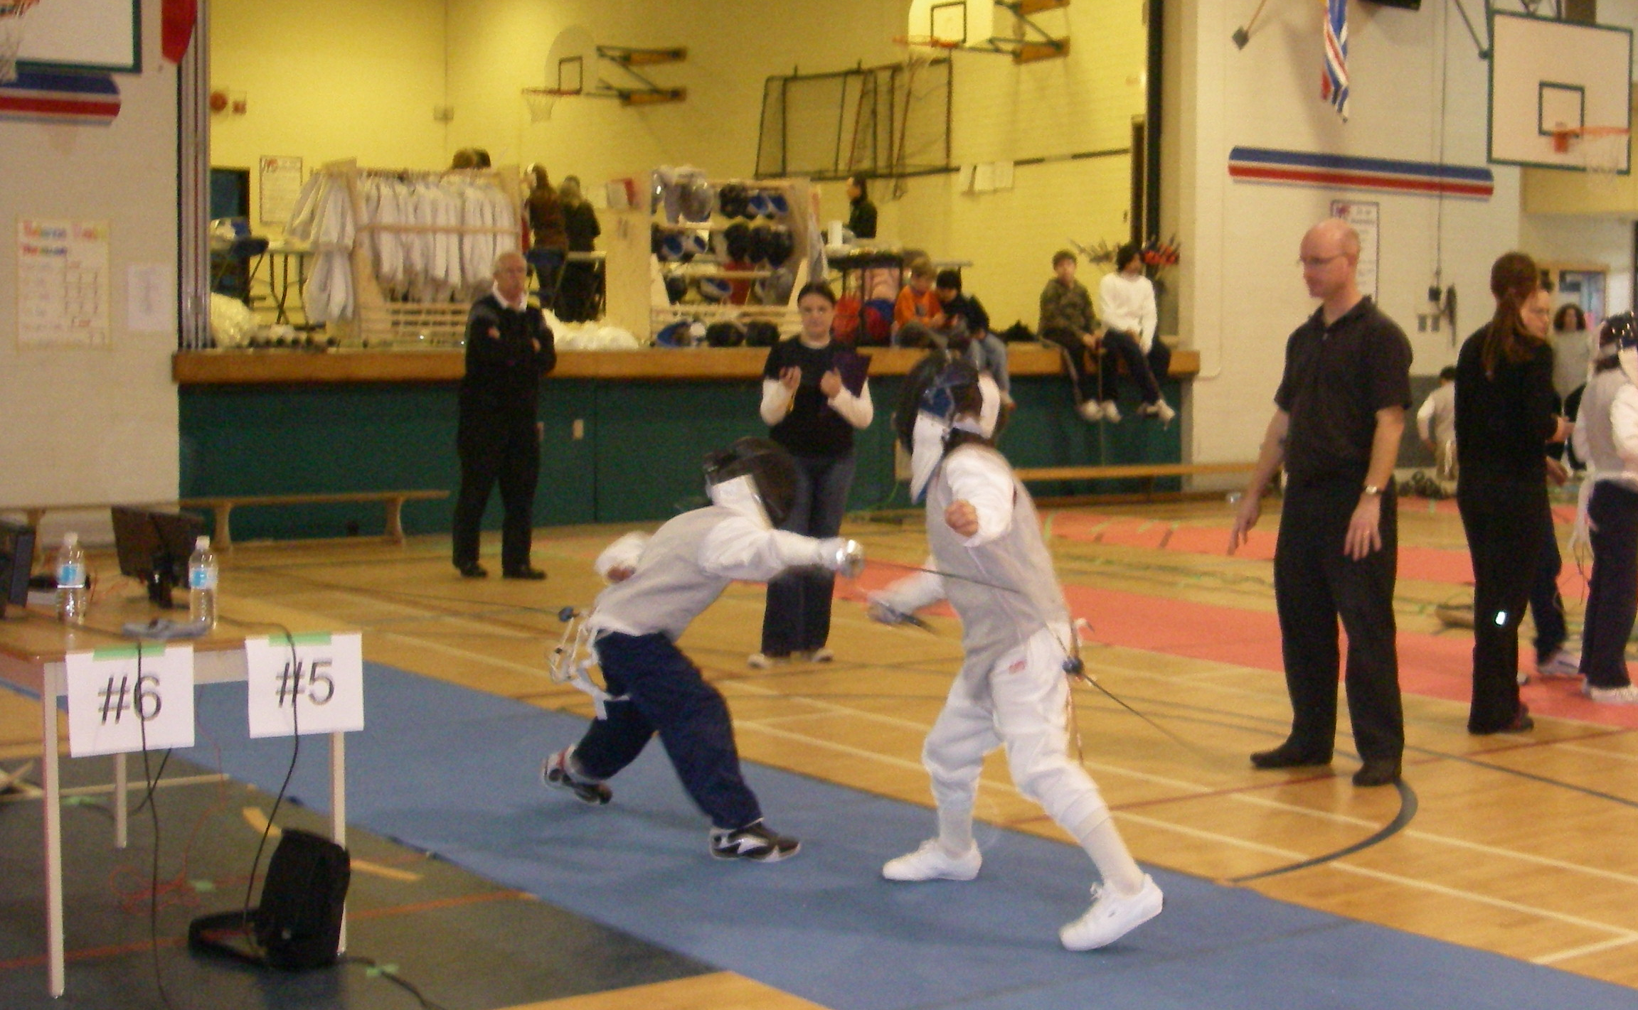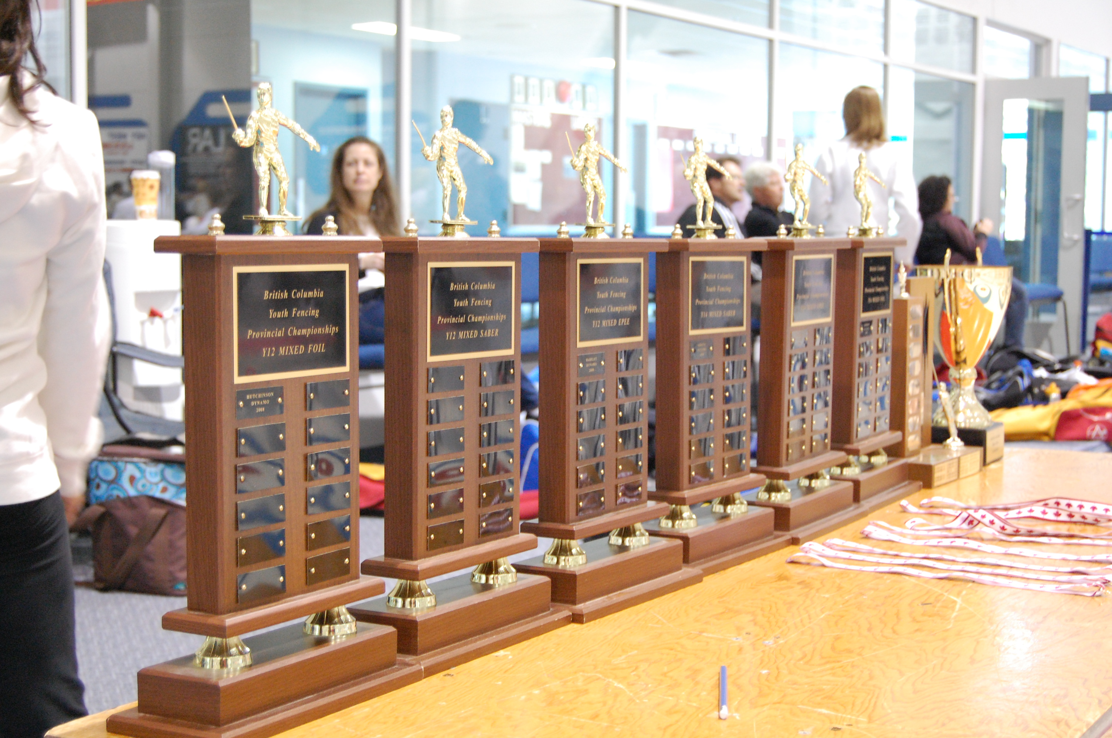

Our instructors are fully insured and have Police Information Checks and First Aid certifications.
We supply all the required safe and modern equipment.
Students only need to bring a water bottle, PE strip, good fitting shoes, and a smile.

After-School Fencing Beginner Class (4 week program):
- 1 hour (2:40-3:40pm) weekly training, after school in your gym
- $16 / student (12 - 15 students)
- Dates: May 4, 11, 18, 25
- Registration and Payment: email brad@tri-cityfencing.com, payment due at first class
- This beginner class prepares students to join any of our Level 1 Training Programs in the Tri-Cities

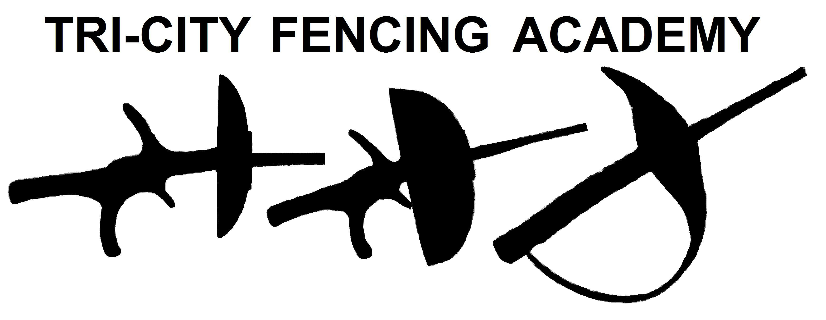
For more information please contact:
Brad Kelly
General Manager, Instructor
brad@tri-cityfencing.com
c: 604-506-1356
www.tri-cityfencing.com

